Course ___Methods_Test 2_ Year __12_______

Student name: ________________ Teacher name: ________________

Date: 30 March

Task type: Response

Time allowed for this task: _____45______ mins

Number of questions: _____9______

Materials required: Calculator with CAS capability (to be provided by the student)

Standard items: Pens (blue/black preferred), pencils (including coloured), sharpener, correction fluid/tape, eraser, ruler, highlighters

Special items: Drawing instruments, templates, notes on one unfolded sheet of
A4 paper, and up to three calculators approved for use in the WACE examinations

Marks available: __46____ marks

Task weighting: __10__%

Formula sheet provided: Yes

Note: All part questions worth more than 2 marks require working to obtain full marks.

Q1 (3.2.1-3.2.3) (3 & 3 = 6 marks)
Determine in terms of for the following.
- given that when .

Solution
Specific behaviours
uses negative indices
anti-differentiates
solves for constant

- given that when .

Solution
Specific behaviours
recognises that numerator is proportional to derivative of brackets
solves for multiplier constant
solves for added constant, accept approx

Q2 (3.2.21-3.2.22) (4 marks)
A particle travels along a straight line such that its acceleration at time seconds is equal to . When the displacement is 22 metres and when
The displacement is -10 metres. Determine the displacement when .

Solution

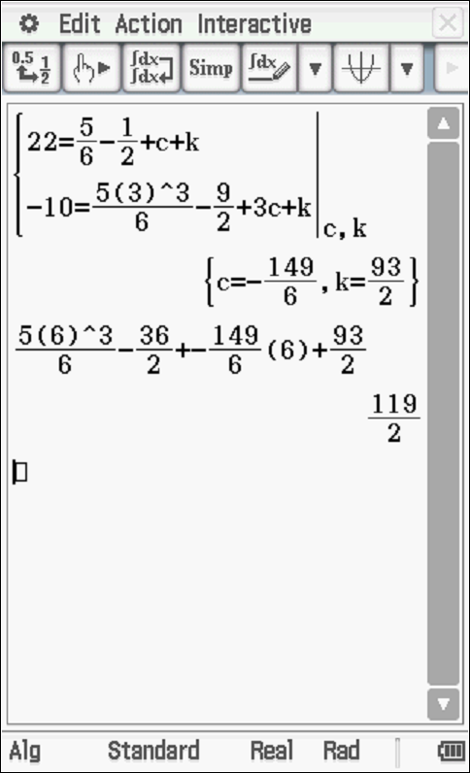

Specific behaviours
determines velocity function
determines displacement function with two constants
solves for both constants
determines displacement at t=6

Q3 (3.2.10-3.2.11) (2. 2, 1 & 2 = 7 marks)
Consider the function which is graphed for .
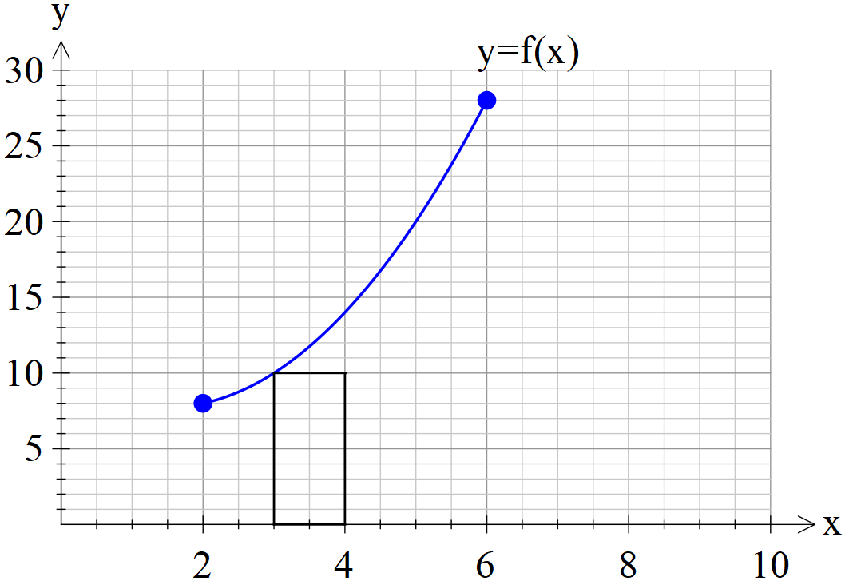

- By using rectangles of width one unit, as shown above, determine a lower estimate for the area under for .

Solution

accept(50 to 54)

Specific behaviours
uses y intercepts from the left of each rectangle
determines sum of areas

- By using rectangles of width one unit, as shown above, determine an upper estimate for the area under for .

Solution

accept (70 to 75)

Specific behaviours
uses y intercepts from the right of each rectangle
determines sum of areas

- Determine a better approximation for the area under for .

Solution
Specific behaviours
determines average

- Describe two different methods to improve the approximation for the area under for .

Solution

Use rectangles of smaller widths

Use calculus with an accurate rule for function

Model parabolas for the top of each rectangle and then integrate

(Note: Trapezium method is the same as averaging upper & lower rectangles therefore do NOT accept)
Specific behaviours
at least one appropriate method
at least two appropriate methods

Q4 (3.2.18-3.2.17) (3 & 2 = 5 marks)

An oil tank is drained of oil such that if of oil in the tank seconds after draining commences is described by .
The initially full tank is emptied in 2 mins.
- How much oil was in the full tank? (nearest kL)

Solution

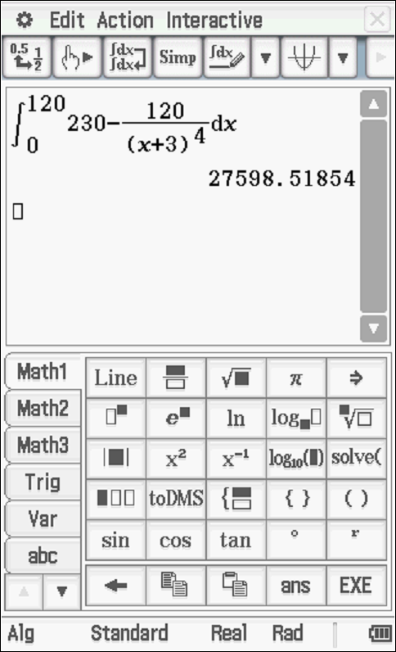

27599 KL

Specific behaviours
uses an integral OR anti-differentiates using 0 to 120 seconds
determines change
rounds change to nearest KL (no need to state units)

- How much oil was drained from the tank in the fifth second, nearest kL.

Solution

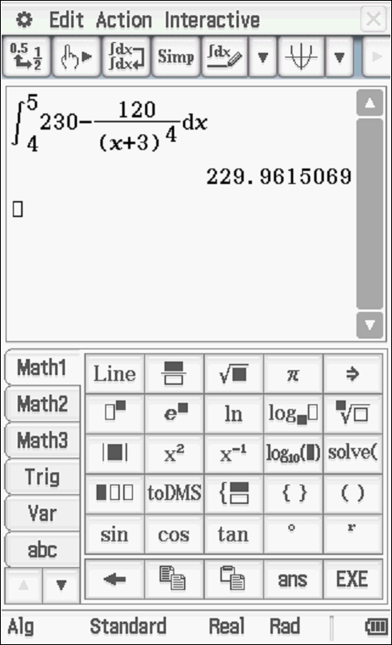

230 KL

Specific behaviours
sets up integral with correct limits OR uses antiderivative with correct limits
states units with answer ( no need for nearest KL)

Q5 (3.2.11-3.2.14) (2, 2 & 2 = 6 marks)
Consider a function which is only defined for with
It is known that for and for .
Determine.

Solution
Specific behaviours
uses fundamental theorem
evaluates integral

Solution
Specific behaviours
uses linearity principle
solves for required integral

- The area between and the x axes for .

Solution

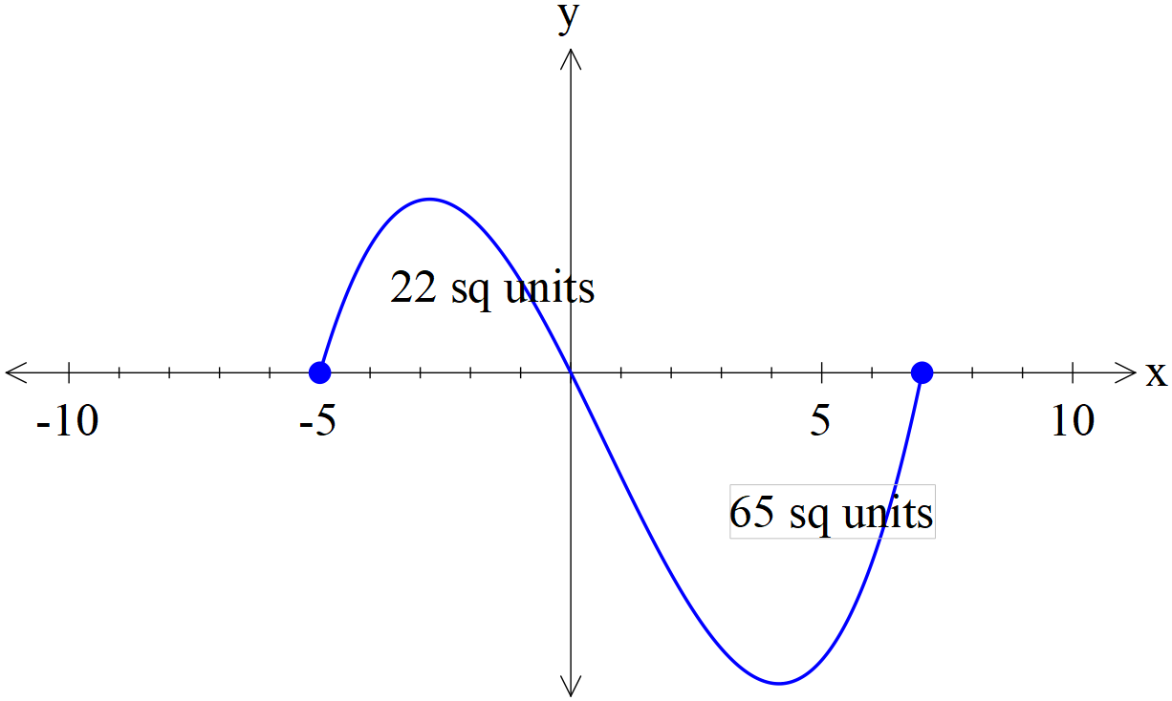

Area= 22 + 65=87 sq units

Specific behaviours
uses absolute value of each integral
determines area

Q6 (3.2.20) (4 marks)
Determine to two decimal places the area between the curves and .
(Hint- Sketch the curves first on your classpad)

Solution

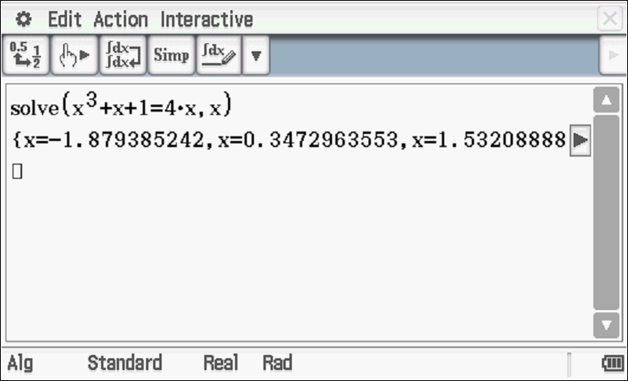

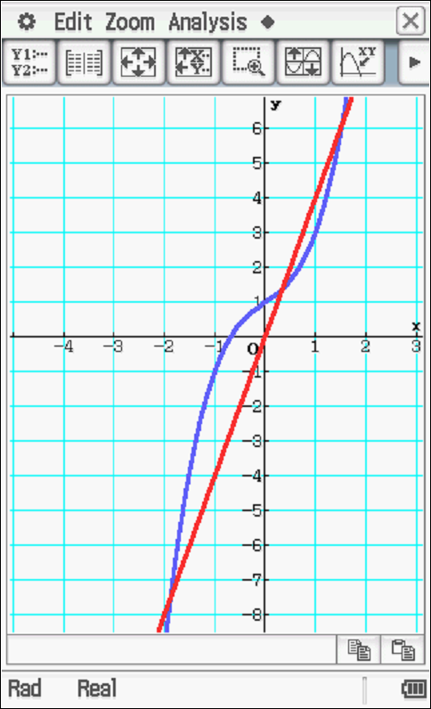

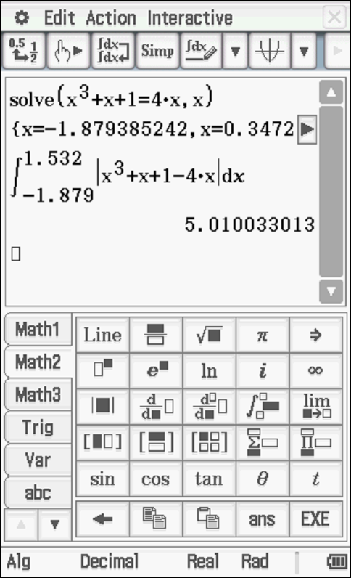

Area = 5.01 sq units
Specific behaviours
determines points of intersection
uses integral with difference between functions OR sets up integral from
uses integrals with absolute values
determines area no need to round to 2 dp

Q7 (3.2.16) (2 & 2 = 4 marks)
Consider
Determine.

Solution
Specific behaviours
uses fundamental theorem
determines derivative in terms of x

Solution
Specific behaviours
uses chain rule correctly
determines derivative

Q8 (3.1.4) (4 marks)
The instantaneous rate of decline in the number of kangaroos on a particular park is 30% of the population per year. If there were 12 050 kangaroos on the park 3 years ago, how many will be on the park in four years from now

Solution

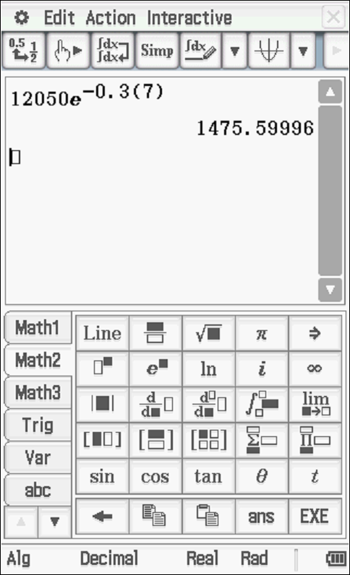

Specific behaviours
recognizes exponential decay
uses correct model of rule
uses correct parameters (both)
determines final population ( no need to round)

Q9 (3.2.6) (6 marks)
- Determine .

Solution
Specific behaviours
uses product rule correctly
determines derivative

- Using your result from part (a) and without using your classpad determine

Solution
Specific behaviours
Uses linearity of antidifferentiation
uses Fundamental Theorem of Calculus
integrates (x+1)1/3 term correctly
Determines integral with a constant

